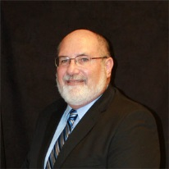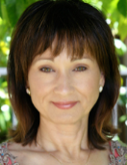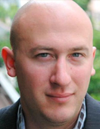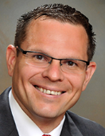 ­­

***An interactive seminar and discussion focused on virtual drug development and strategies for success from discovery to IND.***

**Robert Wenslow, Ph.D.** – Crystal Pharmatech

***How to Identify, Characterize, Select, and Isolate the Optimal Solid State Form for Pharmaceutical Development***

**Brian McMillan** – CoreRx Pharmaceuticals

***Bioavailability and solubility enhancement using multiple techniques including complexation, solid state dispersion, particle size reduction, self micro-emulsifying drug delivery systems (SMEDDS) and liposomes***

**Jack Crawford Ph.D.** – Transposagen Biopharmaceuticals, Inc.

***Effective use of Genome Engineering in Early Drug Development***

**Donna Kato, Ph.D.** and **Barry Calvarese, Ph.D.** - Regulatory Professionals, Inc.

***Essential Steps to Successful IND Submissions***

**Glenn E. Petrie, Ph.D.** – ABC Labs

***The Critical Role of CMC in Your IND Submission***

**Tuesday, November 11, 2014 9:00am – 5:00pm**

#### Hilton Lo Jolla Torrey Pines 10950 North Torrey Pines Rd.

La Jolla, CA 92037

Cost: $199.00 Early Bird by Sept. 30th, 2014

$225.00 Oct. 1st – Nov 8th, 2014

$250.00 At the Door

Registration: 8:00am – 9:00am

Opening Remarks 9:00am – 9:15am

Session 1 9:15am – 10:00am

Session 2 10:00am – 10:45am

Session 3 11:00am – 11:45am

Lunch 12:00pm – 1:00pm

Session 4 1:00pm – 2:15pm

Session 5 2:30pm – 3:15pm

Networking Reception 3:30pm – 5:00pm

##### 

## Strategies for Success in Virtual Drug Development

### Register [Amy.Kaufman@VxPPharma.com](mailto:Amy.Kaufman@VxPPharma.com) or VxPPharma.com/Seminars or call 415-299-0746